Version | 1
Last Revision Date | January 2026
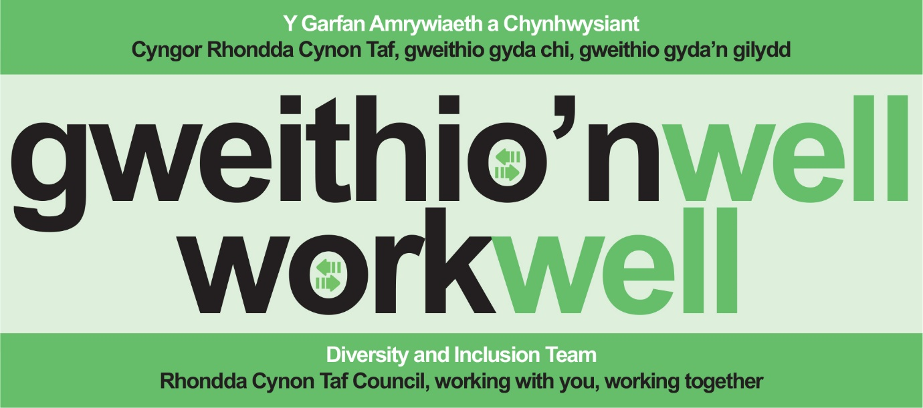
Supporting Muslim Colleagues During Ramadan and Eid
Mae’r adroddiad/canllaw yma ar gael yn Gymraeg, ac mae modd i chi wneud cais i’w weld mewn fformatau ac ieithoedd eraill hefyd.
This report / guidance is available in Welsh and, upon request, other formats, and languages

Supporting Muslim Colleagues During Ramadan and Eid
A practical Guide for Everyone.
Introduction
This guide is designed to help managers, supervisors, and colleagues at the Council understand, support, and accommodate Muslim team members during Ramadan and Eid. By following a person-centred and respectful approach, you foster a more inclusive environment and demonstrate genuine care for your team. Remember, everyone’s experience is personal so respect privacy, avoid assumptions, and ask if you are unsure.
Acknowledgements: This guide was developed in collaboration with the Staff Network Spotlight and with thanks to Dr. Kent (Swansea University) for sharing their Ramadan guide, which informed this resource.
What is Ramadan?
Ramadan is a holy month in the Islamic calendar, dedicated to fasting, reflection, prayer, and community. It is the 9th month of the Islamic lunar calendar and is considered one of the most sacred periods for Muslims worldwide.
- Fasting is one of the 5 Pillars of Islam and is a time for spiritual renewal, increased devotion, and self-discipline.
- Exemptions: Not all Muslims will fast. Exemptions include children, older persons, those who are ill, menstruating individuals, pregnant or breastfeeding women, and travellers. Some may be unable to fast due to chronic illness or frailty; in such cases, they may give fidya (charity) instead.
- Timing: Ramadan begins with the sighting of the new crescent moon, shifting each year by 10–12 days in the Gregorian calendar. It lasts 29 or 30 days, ending with Eid al-Fitr.
- Practices: Most Muslims fast from dawn until sunset, no food or drink (including water) during these hours. The last 10 days are particularly significant, with late-night Taraweeh prayers and Laylat al-Qadr (the 27th night), which may involve staying up all night in prayer.

What is Eid al-Fitr?
Eid al-Fitr marks the end of Ramadan a time of joy, prayer, and family gatherings. It is a major religious holiday, celebrated with communal prayers, festive meals, acts of charity, and visits with family and friends. The date is confirmed by the sighting of the new moon and may only be known a day or two in advance. Flexibility and understanding around leave requests are important at this time.
Key Facts and Workplace Considerations
- Charity: Ramadan emphasizes generosity. Muslims give zakat (obligatory charity) and sadaqah (voluntary charity).
- Children: Fasting becomes compulsory from puberty (usually ages 12–14), but children are not required to fast and should not be pressured. Some may choose to participate partially.
- Missed Fasts: Missed fasts due to temporary reasons (illness, travel, menstruation) can be made up later. Chronic inability to fast is addressed through fidya (providing meals to those in need).
- Eid Leave: Eid can last up to three days. Be supportive and flexible with annual leave requests.

How Managers and Colleagues Can Support
- Flexible Working: Offer flexibility in start and finish times to accommodate fatigue or prayer schedules.
- Meetings and Events: Schedule important meetings outside fasting hours if possible; avoid lunchtime gatherings with food.
- Breaks: Allow additional short breaks for prayer, reflection, or rest, especially later in the day.
- Prayer Space: Ensure access to a quiet, private space for prayer if requested.
- Be Mindful: Avoid offering food or drinks during fasting hours and be considerate in social situations.
- Show Interest: If appropriate, ask colleagues what support would be most helpful.

Inclusive Language – What to Say and What to Avoid
- Use respectful greetings: “Ramadan Mubarak” or “Eid Mubarak” (“Blessed Ramadan/Eid”).
- Avoid assumptions - ask, “Are you observing Ramadan?” or “Will you be celebrating Eid?” rather than assuming.
- Be considerate - avoid comments about food, fasting, or religious practices that may sound insensitive.
- Foster respect - encourage an environment where colleagues feel comfortable sharing their needs or experiences.

Practical Checklist
- Be person-centred: Ask colleagues about their needs and respect privacy.
- Offer flexibility: Adjust working hours and breaks as needed.
- Be mindful: Avoid food-related activities and be considerate in meetings.
- Use inclusive language: Choose respectful greetings and avoid assumptions.
- Accommodate Eid: Support leave requests and acknowledge the holiday.
- Foster respect: Create a welcoming, open environment.

Further Resources
- Equality and Human Rights Commission: Religion or belief in the workplace
- ACAS: Religion or belief discrimination
- Muslim Council of Britain: Ramadan resources

For questions about Ramadan or Eid, contact the Diversity and Inclusion Team:
equality@rctcbc.gov.uk
This guide is available in Welsh and, upon request, in other formats and languages.

