Version | EN1
Last Revision Date | May 2023

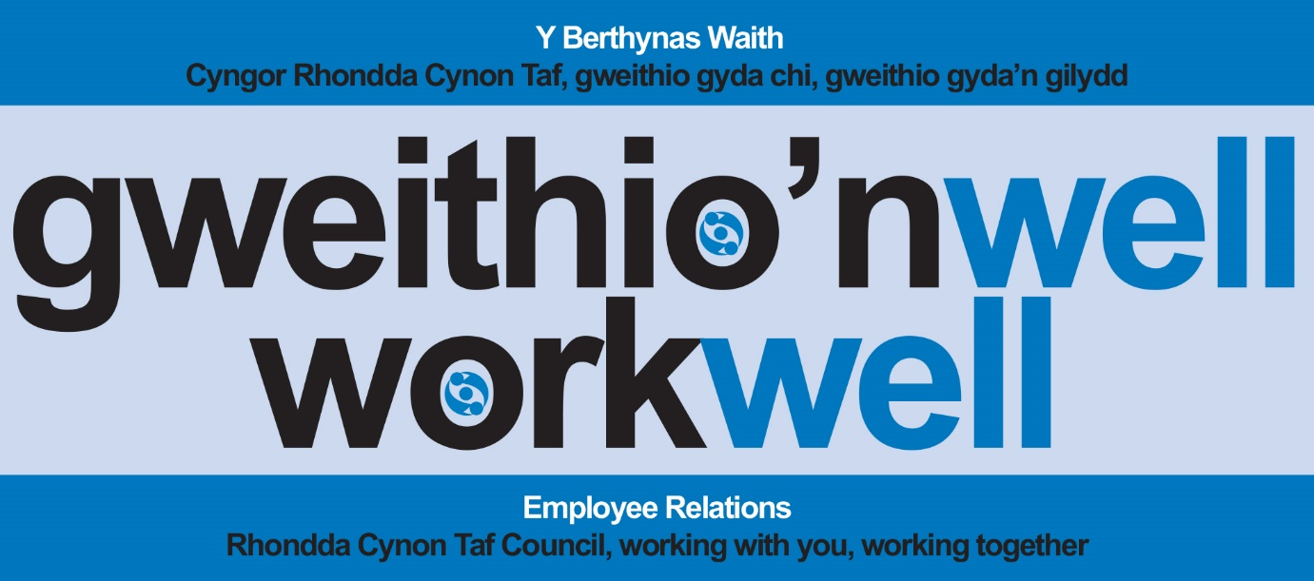

Operating Model
Flexi-time Working Hours Policy

Mae’r ddogfen hon ar gael yn Gymraeg/This document is also available in Welsh

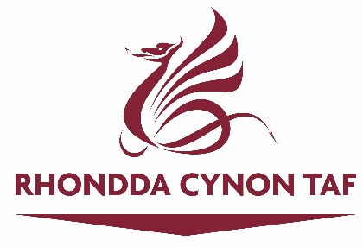

DOCUMENT CONTROL
POLICY NAME | Operating Model - Flexi-time Working Hours Policy
Department | Human Resources
Telephone Number | (01443) 570037/(01443) 444503
Initial Policy Launch Date | May 2023
Reviewing Officers | Deborah Hughes, Peter Cushion, Ian Traylor
Review Date | May 2024
Date of Equality Impact Assessment
REVISION HISTORY
Date | Revised By
May 2023 | SLT
DOCUMENT APPROVAL
This document has received approval from: |  | Date of Approval
HR Senior Management Team |  | N/A
Senior Leadership Team |  | May 2023
Cabinet |  | N/A

CONTENTS

1. Introduction 1
Benefits To The Council 1
Benefits To The Employee 1
2. Definition Of Terms 2
2.1 Flexitime Hours Bandwidth 2
2.2 Core Office Opening Hours (8.30 To 5) 2
2.3 Settlement Period 2
2.4 Contracted Hours 2
2.5 Credit Balances 3
2.6 Debits (Hours Owed) 3
2.7 Compensatory Leave 3
3. Application of Scheme 3
4. Manager Responsibilities 3
5. Employee Responsibilities 4
6. Constraints 5
7. The Working Day 5
8. Health and Safety 5
9. Designated Breaks 6
Religious Observances 6
Phased Return 6
Travelling Time 6
10. Standard Working Times 6
11. Settlement Period 7
12. Contracted Hours 7
13. Maximum Hours to be Worked in a Week 7
14. Minimum Attendance Hours When Taking Leave 7
15. Carry Over Balances 7
16. Post Entry/Qualification Courses 8
17. Training Courses, Seminars and Conferences 9
18. Overtime Working 9
19. Recording of Attendance 9
20. Termination of Employment 9
21. Environmental Considerations 10
22. Abuse of Scheme 10

INTRODUCTION

Rhondda Cynon Taf Council is committed to being an employer that supports a positive Work Life Balance. The Flexi Working Hours scheme enables staff to have greater autonomy over the times that they begin and end work and the breaks that they take during their day subject to certain constraints.

- It is a fundamental requirement that levels of service provided are maintained (and where possible, improved).
- Excellent customer care is paramount; employees must ensure that staffing levels are maintained during the normal working day, including lunch time and other breaks.
- It is the individual’s responsibility to ensure that they work their full contracted hours.
- Managers and employees are responsible for administering and managing the Flexi Working Hours Scheme within their own teams.
- Increased flexibility is not an automatic entitlement and at all times the provision of a quality service is paramount.
- Flexible working can improve not only the service but the lives of employees and should be treated as a benefit and a responsibility.
- Employees should not be working excessive hours and should be mindful of their health and well-being.

Benefits to the Council

- Improved retention, therefore less time and money spent on recruiting and training staff.
- A more flexible workforce that responds to peaks and troughs in work and can respond more effectively to customers outside of traditional core business hours of 8.30am to 5pm.
- Improved service provision.
- A positive effect on absenteeism and productivity.
- Employees feeling more motivated.
- Better communications within and between teams.
- Reduced staff costs due to less overtime payments

Benefits to the Employee

- Time to balance interests and responsibilities both within and outside of work.
- Benefits for parents in enabling them to attend important events with their children.
- Also recognises staff with other priorities and commitments which are personal to them.
- Reduced stress, improved self-esteem and greater control over working lives.
- Increased loyalty and commitment.
- Encourages better relations between managers and teams.

DEFINITION OF TERMS

In describing any scheme of flexible working hours, a number of terms are used which may be unfamiliar to employees new to this method of arranging the working day. So that there shall be no confusion over their precise meaning, the most common of them are listed below together with the meanings assigned to them for the purpose of this Scheme.

2.1 Flexitime Hours Bandwidth

This is the part of the day ranging from the earliest time at which anyone can start work through to the latest possible finishing time (excluding overtime). Please note that the bandwidth times listed in point 5 below are subject to the needs of the Council service delivery. Any operation of hours outside the Core Office Opening Hours will need to be agreed with your manager in line with the requirements of your role.

2.2 Core Office Opening Hours (8.30 to 5)

The times during which every office will be open to the public either face to face or virtually. Adequate cover must be maintained during this period.

2.3 Settlement Period

This is a four-week period over which working time is calculated it is often known as a flexi period.

2.4 Contracted Hours

This is the total number of hours each employee is contracted to work for the Council.

2.5 Credit Balances

The scheme allows employees to work more than their contracted hours in a settlement period where required by the role. Up to 8 hours can be carried forward from one flexi period into another.

2.6 Debits (Hours Owed)

Only in exceptional circumstances will a debit balance be agreed. This will be subject to agreement by the employing Director and must be cleared in the next settlement period.

2.7 Compensatory Leave

Compensatory leave of 1 day (or 2 half days) can be taken in any one settlement period where there are sufficient credit hours. This can only be with the prior approval of the appropriate line manager.

APPLICATION OF SCHEME

It is important to recognise that the Scheme is a benefit and not a contractual right and not all service areas will be able to access the scheme, as it will depend upon the business needs of the Service.

Please note that where the scheme is in operation, if the scheme is not respected, then its use will be withdrawn from individual employees at the discretion of the Director/ Service Director and Director of Human Resources.

This scheme does not apply to Chief Officers within the Council.

MANAGER RESPONSIBILITIES

- The needs of service users, the organisation and other employees must be taken in to account to ensure that a quality service is maintained at all times.
- Any scheme must be operated fairly and reasonably.
- Managers need to ensure that hours worked by staff are aligned to the business needs of service users and/or the organisation.
- To ensure that the hours worked by staff are not too irregular and are not excessive.
- Working patterns of individuals do not have a detrimental effect on other team members.
- To familiarise themselves with the Flexi Scheme, in particular their responsibilities and how to manage abuse of the scheme.
- It is essential for managers and employees to work together to plan satisfactory cover to provide an effective service. The manager will be ultimately responsible for the efficient operation of the service.
- On occasions where a manager cannot approve a request for flexi leave, the manager should explain the business grounds for refusing the request. Employees must understand that managers have a right to refuse their request if business needs require them to be present at a certain time.
- To advise employees of the appropriate scheme in place for the service area and how to work the flexi system if appropriate.
- Credit balances are authorised and checked at the end of each four-week settlement period.
- Flexi leave is recorded and approved on the appropriate electronic system prior to the leave being taken.

EMPLOYEE RESPONSIBILITIES

- Common sense and goodwill are paramount in the success of the scheme and employees should give due regard to their own workload and that of their team, with large fluctuations in the distribution of hours of work being avoided.
- To ensure that hours accrued are in line with the genuine work needs of their role.
- To ensure that managers are made aware of work pressures should the employee accrue additional hours each period.
- To ensure that contractual hours are achieved and the flexi system that records hours is up to date and accurate.
- To ensure with their team that service provision is always paramount and that adequate cover is maintained between the team throughout the day. With a wider bandwidth, this may require more communication, planning and organisation than previously.
- To discuss and agree with their manager requests for time off under the Flexi Scheme, prior to taking leave.
- To recognise that there is no automatic entitlement to flexi-leave, and that at all times managers must take into account service needs when considering requests for leave.
- To be flexible in working with colleagues to ensure that the needs of the service users, the organisation and other employees are achieved.
- To comply with the requirements of the Flexi Scheme, and not to abuse the Scheme.
- When signing in electronically, employees must state exact times of arrival and departure, and not ‘round up or down’ to nearest 5 minutes.
- To work the hours when work is available and which meets the needs of service users and the organisation.
- To bring to the attention of management any difficulties or problems in the operation of the Scheme.
- To co-operate with management in the effective implementation and monitoring of the Scheme.

CONSTRAINTS

The success of the scheme depends on the common sense and goodwill of both employees and managers and requires a co-operative approach. It is expected that employees, when necessary, will arrange their times of work to have regard to their current personal workload or the overall pattern of work in their section/service area. A line manager may require an employee to work at specified times on any day if the exigencies of the service so demand.

Under this scheme the core office hours are 8.30 – 5 pm Monday to Friday and must be adequately covered at all times, either face to face or virtually, to deal with enquiries whether made in person or by telephone. It is expected that employees will arrange between themselves to keep offices properly covered, but if agreement is not forthcoming or for any other specific reasons, employees will be asked to revise their working hours to ensure that adequate cover is provided.

THE WORKING DAY

The working day has been established as follows:

Flexible Hours Bandwidth - From 06.00 to 20.00 hours daily

The above times apply for all days of the normal working week (Monday to Friday).

Please note that the above is subject to:

- Work location opening hours (for those that attend either full time due to their work requirements or via the Office Hybrid/ Agile models.
- an employee’s work specific system being available at this time e.g., if an employee’s work system is not available until 7.30am then staff will not be able to accrue time before this point)

HEALTH AND SAFETY

- When flexible working involves working outside core office opening hours, staff must be aware of their own safety and adhere to the lone working policy and Health and Safety Procedures.
- The scheme does not encourage longer working hours.

DESIGNATED BREAKS

Employees who work over 6 hours per day must take a break (subject to the constraints outlined in points 4) of not less than 30 minutes in duration. Employees must ensure that their break period is recorded irrespective of whether they leave their place of work/ home office set-up. They must also clock out for every period of time that they are not available for work during the bandwidth.

Religious observances

Managers should, where operationally possible, assist employees to meet their religious observances. This consideration should be taken in line with annual leave and / or flexi – leave for specific days but should also be considered for any daily religious observances. Any break from work must be recorded.

Phased return

When an employee returns to work following a period of sickness absence, following medical advice a phased return may be agreed. Employees should only claim their standard hours during the phased return.

Travelling time

Where an employee spends part of a day on site and either travels directly from home to site or directly from site to home, the time recorded should reflect the provisions of the Scheme for payment of travel expenses and redeployment e.g., if travelling to or from staff’s fixed centre, the working day starts and ends at the fixed centre. Alternatively, if travelling to another base or from home, then the shorter distance and time rule will apply.

Similarly, staff cannot claim flexi time, or expenses for travelling to and from their fixed base for part of a day e.g., if starting the day working from home, travelling to their fixed base for a meeting, returning to work from home following the meeting – the time spent travelling cannot be claimed as flexi and travel expenses cannot be claimed.

STANDARD WORKING TIMES

For the purpose of crediting annual leave, sickness and other authorised absences the following times will apply based on full time employee:

WEEK 37 hours (pro rata for part time employees)
DAY 7 hours 24 minutes
HALF-DAY 3 hours 42 minutes

Staff have to work a minimum of 6 hours per day (unless an employee’s normal working day is less than this e.g., reduced hours). However, the hours of operation will need to meet the requirements of the role they undertake.

NB - For part time employees the week/day/half-day/minimum hours above maybe pro-rata but this will depend upon the employees’ pattern of work.

SETTLEMENT PERIOD

The settlement period is 4 weeks, at the end of which a balance has to be reached to show how many hours were actually worked as compared to contracted hours.

CONTRACTED HOURS

The total of contracted hours that must normally be worked in any one settlement period is the product of the number of hours currently worked in the standard week (37 for a full-time employee) multiplied by the number of weeks in the settlement period (4), i.e., 148 hours. Hours will be pro-rata for part time employees.

MAXIMUM HOURS TO BE WORKED IN A WEEK

The maximum number of working hours that can be accrued is limited to the Working Time Directive of 48 hours. Only in exceptional circumstances and with the agreement of your chief officer can hours be worked above this limit.

Employees and managers are required to arrange their hours of work so as to avoid large fluctuations in the distribution of such hours and ensure that workloads are managed and the work location is appropriately covered.

MINIMUM ATTENDANCE HOURS WHEN TAKING LEAVE

Employees are required to work a minimum of 3 hours per day (of core office hours), prior to/after taking leave, whether that is half day annual leave or a compensatory half day flexi.

CARRY OVER BALANCES

The maximum number of credit hours which may be carried forward, to the next settlement period only, are 8 hours.

Credit hours may be taken within the same period as they are earned. With the agreement of the manager, the credit hours may be taken in the form of compensatory leave up to a maximum of 1 whole days (7.24 hrs) or 2 half-days (3.42 hrs).

In regard to part time employees, the flexi leave may or may not be pro-rata. Whilst not an exhaustive list, the following examples are aimed at providing clarity on this matter.

1 | Employee works 30 hrs over 5 days i.e., 6 hours per day. | Employee would be entitled to either a day off or two half-days but this would be on based on 6 hrs and 3 hrs respectively.
2 | Employee works 18.5 hrs over 5 days i.e., 3.42 hours per day. | Employee would be entitled to a day off (half days will not apply) but that one day would be on based on 3.42 hrs.
3 | Employee works 18.5 hrs over 3 days i.e., 7.24 hours for two days and 3.42 hrs for third day. | Similar to annual leave calculations, the day off would be on a pro-rata basis i.e., 3/5 of one day (half-days will not apply) which equates to a half day compensatory leave of 3.42 hrs. An alternative would be to take 1 full day every other flexi period.
4 | Employee works 30 hrs over 4 days i.e., 7.24 hours per day | Similar to annual leave calculations, the day off would be on a pro-rata basis i.e., 4/5 of one day which equates to 10 days per year.

POST ENTRY/QUALIFICATION COURSES

Credit hours for employees undertaking qualification courses will be up to a maximum of the standard working day as follows:

- Full day (i.e., day release) – up to 7 hours 24 minutes
- Half day (i.e., full morning/afternoon) – up to 3 hours 42 minutes

No credit can be claimed for courses undertaken outside of the normal working day i.e., evening courses. Time off in lieu (TOIL), plain time overtime or any enhancements will also not apply.

Please refer to the Training, Learning & Development Policy for further information.

TRAINING COURSES, SEMINARS AND CONFERENCES

For full or part time employees on seminars, conferences and non-qualification courses where attendance occurs on a normal working day, individuals will be credited hours for attendance at the course or event. In the case of this scheme, hours will be credited as 7 hours 24 minutes for a full day and 3 hours 42 minutes for a half-day. There is no entitlement to claim flexitime credit for travelling or an overnight stay.

Please refer to the Training, Learning & Development Policy for further information.

OVERTIME WORKING

Without exception, all overtime must be authorised by the manager beforehand. Overtime claims must be submitted at the end of the settlement period. Overtime payments may be made for hours worked on weekends when the flexi-time scheme does not apply.

RECORDING OF ATTENDANCE

Employees are required to record their attendance and absences in accordance with the approved procedures and are individually responsible for the accurate recording of their working hours. Under no circumstances whatsoever, should an employee record hours worked on behalf of another employee.

At the commencement of work, an employee must confirm their attendance by signing in, also when they finish work, they must sign out in the same way. Departure and return from the ‘designated break’ must also be recorded in this way regardless of whether or not employees leave their work location. When signing in, employees must state exact times of arrival and departure, and not ‘round up or down’ to nearest 5 minutes.

Any ‘additional break’ outside the ‘designated break’ must also be recorded.

TERMINATION OF EMPLOYMENT

When an employee terminates employment with the Authority, the manager will need to ensure that the employee has worked the full number of contracted hours appropriate to the stage of the accounting period reached at the date of termination (any debit balance at the end of this period will be subject to an adjustment of pay, unless agreed by the employing Director).

During the last settlement period (or part period) of service with the Council, an employee may continue to work Flexible Working Hours on the clear understanding that they work their full contracted hours: failure to work contracted hours will also necessitate an adjustment to the employee’s salary and possible delay in its payment.

ENVIRONMENTAL CONSIDERATIONS

When employees attend an office, all employees are asked to be mindful of switching equipment off when they leave, and not switching on any more lights than necessary when they arrive at work. However, other ways of saving energy can be adopted, for example, the Carbon Trust state that if a monitor is turned off when not being used (including lunchtimes, etc), and the standby options are activated, energy consumption can be reduced by 90% per year.

ABUSE OF SCHEME

Because Flexible Working Hours hinge on trust, abuse of the scheme will be regarded as gross misconduct and the offending employee will be dealt with in accordance with Rhondda Cynon Taf Council's disciplinary procedures.

