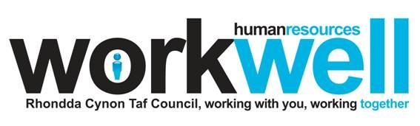

**Rhondda Cynon Taf Council Competency Framework:**

**Compiling a Person Specification for e-Recruitment**



# Content

**Page**

**Introduction – Compiling a Person Specification for e-**

**3 Recruitment**

**Decision Tree 6**

**Overview 7**

# Writing Person Specifications

**Background**

Recent updates and improvements to the e-recruitment system mean that any vacancies being advertised will need the Person Specification to reflect the current competency framework. If existing Job Descriptions and Person Specifications have competencies from the old framework then these will need to be revised.

Please note, these updates only affect the content of the Person Specification, there is no requirement to change the Job Description. If there are any changes to Job Descriptions these would need to be verified through the correct channels – Line

Manager / Head of Service / Human Resources / Job Evaluation / Change Control.

## Updating the Person Specification

### First Step – The Person / People

Before you start updating the Person Specification you will need to think about the type of person you require in the role, the skills, aptitudes and behaviours they will need to possess, demonstrate or develop to successfully fulfil the role requirements.

Once you have done this and have a clear picture in your head of what is required you are then ready to look at the Competency Framework.

### Second Step - Choosing the Job Family

To update the Person Specification you will need to decide which Job Family the role best falls in to - the decision tree will assist with this (page 3).

There are 9 job families:

* Administrator Framework
* Ancillary Framework
* Community & Social Care Framework including Social Care Professionals
* Frontline & Customer Care Framework
* Middle Manager Framework
* Strategic Manager Framework
* Skilled Manual Worker Framework
* Supervisory Framework
* Technical, Specialist, Professional Framework

Once you have identified the job family using the Decision Tree you will need to read through the statements to ensure they meet your requirements. This is a useful checking point as you need to be satisfied that the correct job family has been selected. There is no point in choosing a job family where the competencies have little or no relevance to the role.

### Third Step – Choosing the statements for the Person Specification

Each job family has a number of Competency Areas (main headings), some of these are reflected across all job families and some are more specific to job types. Under these main headings are the statements about behaviours, aptitudes and skills.

**It is recommended that a Person Specification has a minimum of 2 and a maximum of 8 Competency Areas (headings), and under each of these headings a maximum of 2 statements.**

### Fourth Step – Choosing the best statements to recruit against

Once you have chosen the headings and statements you feel are most applicable to the role you will then need to choose from these the competency statements you would like candidates to provide evidence against on the application form.

**When it comes to advertising a post via the iTrent recruitment system** unlike the Council’s previous system, managers will not be able to select items from the Council’s competency framework to populate the online application form. Instead, there are 3 question sets available for each of the frameworks (administrator’s framework, technical specialist framework etc) that will allow applicants to provide evidence of their suitability for the role they are applying for.

**.**

## General Guidance

When updating your old version Job Descriptions and Person Specifications you may be tempted to try to match ‘like-for-like’, that is try to find statements within the new framework that reflect the old framework statements. This is not recommended for the following reasons:

### • The Old Framework

In 2007 the Council commenced a thorough review of the existing Competency Framework following feedback from Council staff raising concerns around areas including relevance and understanding / language. Consultation sessions were set up allowing staff to feedback their concerns, thoughts and suggestions as to what was needed. This took place through a range of mediums including Focus Groups, questionnaires and 1-2-1’s, the whole process taking approximately 18 months to administer.

The review of the Competency Framework highlighted a range of recommendations for improvement. Employees wanted the competencies to be far more role specific and this resulted in the new Competency Framework which was launched in 2009.

Feedback of the new competency framework from managers and employees has been very positive, describing the frameworks as more relevant to individual roles, user friendly and written in a language that is easier to understand than the previous framework.

With this in mind it would seem pointless trying to replicate statements from a framework that managers and employees didn’t feel were that relevant to the posts. You will find it more beneficial to ignore the competencies on your old Person Specification and choose what you feel is most applicable from the new framework – this will give you the opportunity to choose the statements you feel are most desirable for the role as it stands now. (This doesn’t stop you from using your old JD/PS as a reference point.)

### • Time

The new framework is very different to the previous framework and it can therefore be very time-consuming trying to find statements that ‘match’.

## Further Support

Your Human Resources representatives will look over anything you put together. If you want advice or guidance on using the Competency Framework please contact your HR representative.

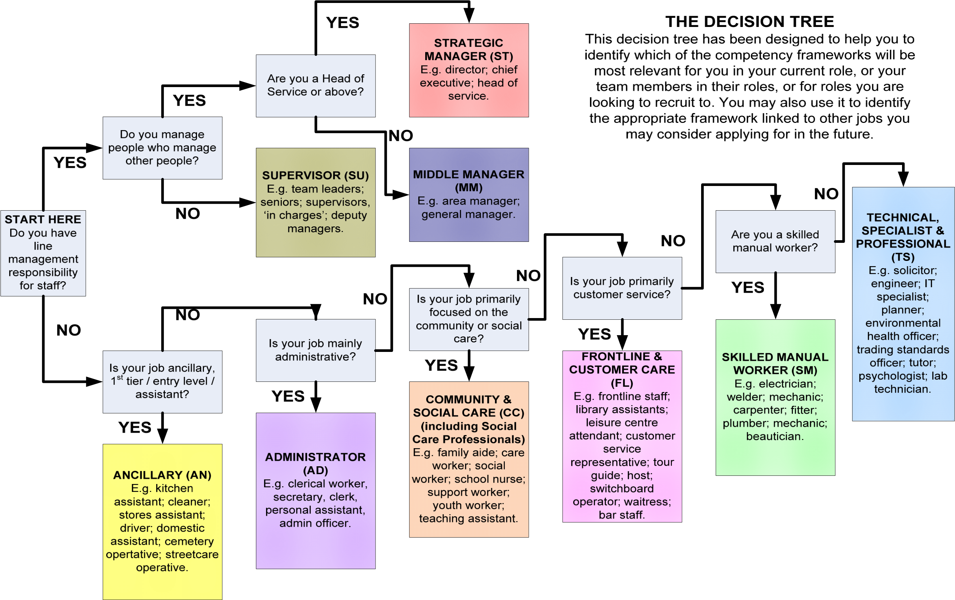

RCT Council Page 6 of 8 Competency Framework

Overview of All Competency Headings for All Job Families

|  |  |  |  |  |  |  |  |  |  |  |  |  |
| --- | --- | --- | --- | --- | --- | --- | --- | --- | --- | --- | --- | --- |
| Administrator AD | Working in a  Team (1) | Communicating  Effectively (3) | Achieving  Results  (4) | Personal  Effectiveness (5) | Focusing on  Service Users  (7) | Complying with Health  and Safety  (8) |  |  |  |  |  |  |
| Ancillary  AN | Working with  Others (1) | Communicating  Effectively (3) |  | Being  Committed and  Reliable (5) |  | Working  Safely (8) | Demonstrating  Technical  Ability (9) |  |  |  |  |  |
| Community &  Social Care  CC | Working with  Partners (1)  Working with  Team  Members (2) | Communicating  Effectively (3) | Achieving  Results  (4) |  | Looking  After Service  Users’ Best  Interests (7)  Earning  Service  Users’ Trust  (15) | Complyin  g with Health and  Safety (8) | Encouraging  Professional  Development  (9) | Working with Change  (10) |  |  |  |  |
| Frontline and  Customer  Care  FL | Working  Effectively with  Others (1) | Communicating  Effectively (3) | Achieving  Results  (4) | Demonstrating  Professionalism  (5) | Meeting  Customers’  Needs (7) | Maintaining  Safety and  Well-being  (8) | Demonstrating  Technical Ability  (9) |  |  |  |  |  |
| Middle  Manager  MM | Working in Partnerships  and Teams  (2) | Communicating  Effectively (3) | Achieving  Results  (4) |  | Focusing on  Service Users  (7) |  |  | Managing Change (10) | Implementing Strategy (11) | Political  Knowledge and Awareness  (12) | Managing  Resources  (13) | Developing and Motivating  People (14) |
| Strategic Manager  ST | Working in Partnerships  and Teams  (2) | Communicating  Effectively (3) | Achieving  Results  (4) |  | Focusing on  Service Users  (7) |  |  | Leading  Change (10) | Working  Strategically  (11) | Political  Knowledge and Awareness  (12) | Managing  Resources  (13) | Developing and Motivating  People (14) |
| Skilled  Manual  Worker  SM | Working with  Others (1) | Communicating  Effectively (3) |  | Being  Committed and  Reliable (5) | Working with  Service Users  (7) | Working  Safely (8) | Demonstrating  Technical Ability  (9) |  |  |  |  |  |
| Supervisor  SU | Working as a  Team Member  (2) | Communicating  Effectively (3) | Achieving  Results  (4) | Managing Time  (5)  Being  Accountable (6) | Focusing on  Service Users  (7) | Complying with Health  and Safety  (8) | Encouraging  Professional  Development (9) | Incorporating  Change (10) |  |  |  | Leading and Motivating  (14) |
| Technical,  Specialist,  RCT Council Professional  TS | Working in Partnerships  and Teams  (1) | Communicating  Effectively (3) | Achieving  Results  (4) | Being  Accountable (6) | Focusing on  Service Users  (7) | Page 7 of 8 | Professional Expertise and  Development (9) | Creating and  Responding  to Change Compete  (10) | ncy Framew | ork | Managing  Resources  (13) |  |

RCT Council Page 8 of 8 Competency Framework