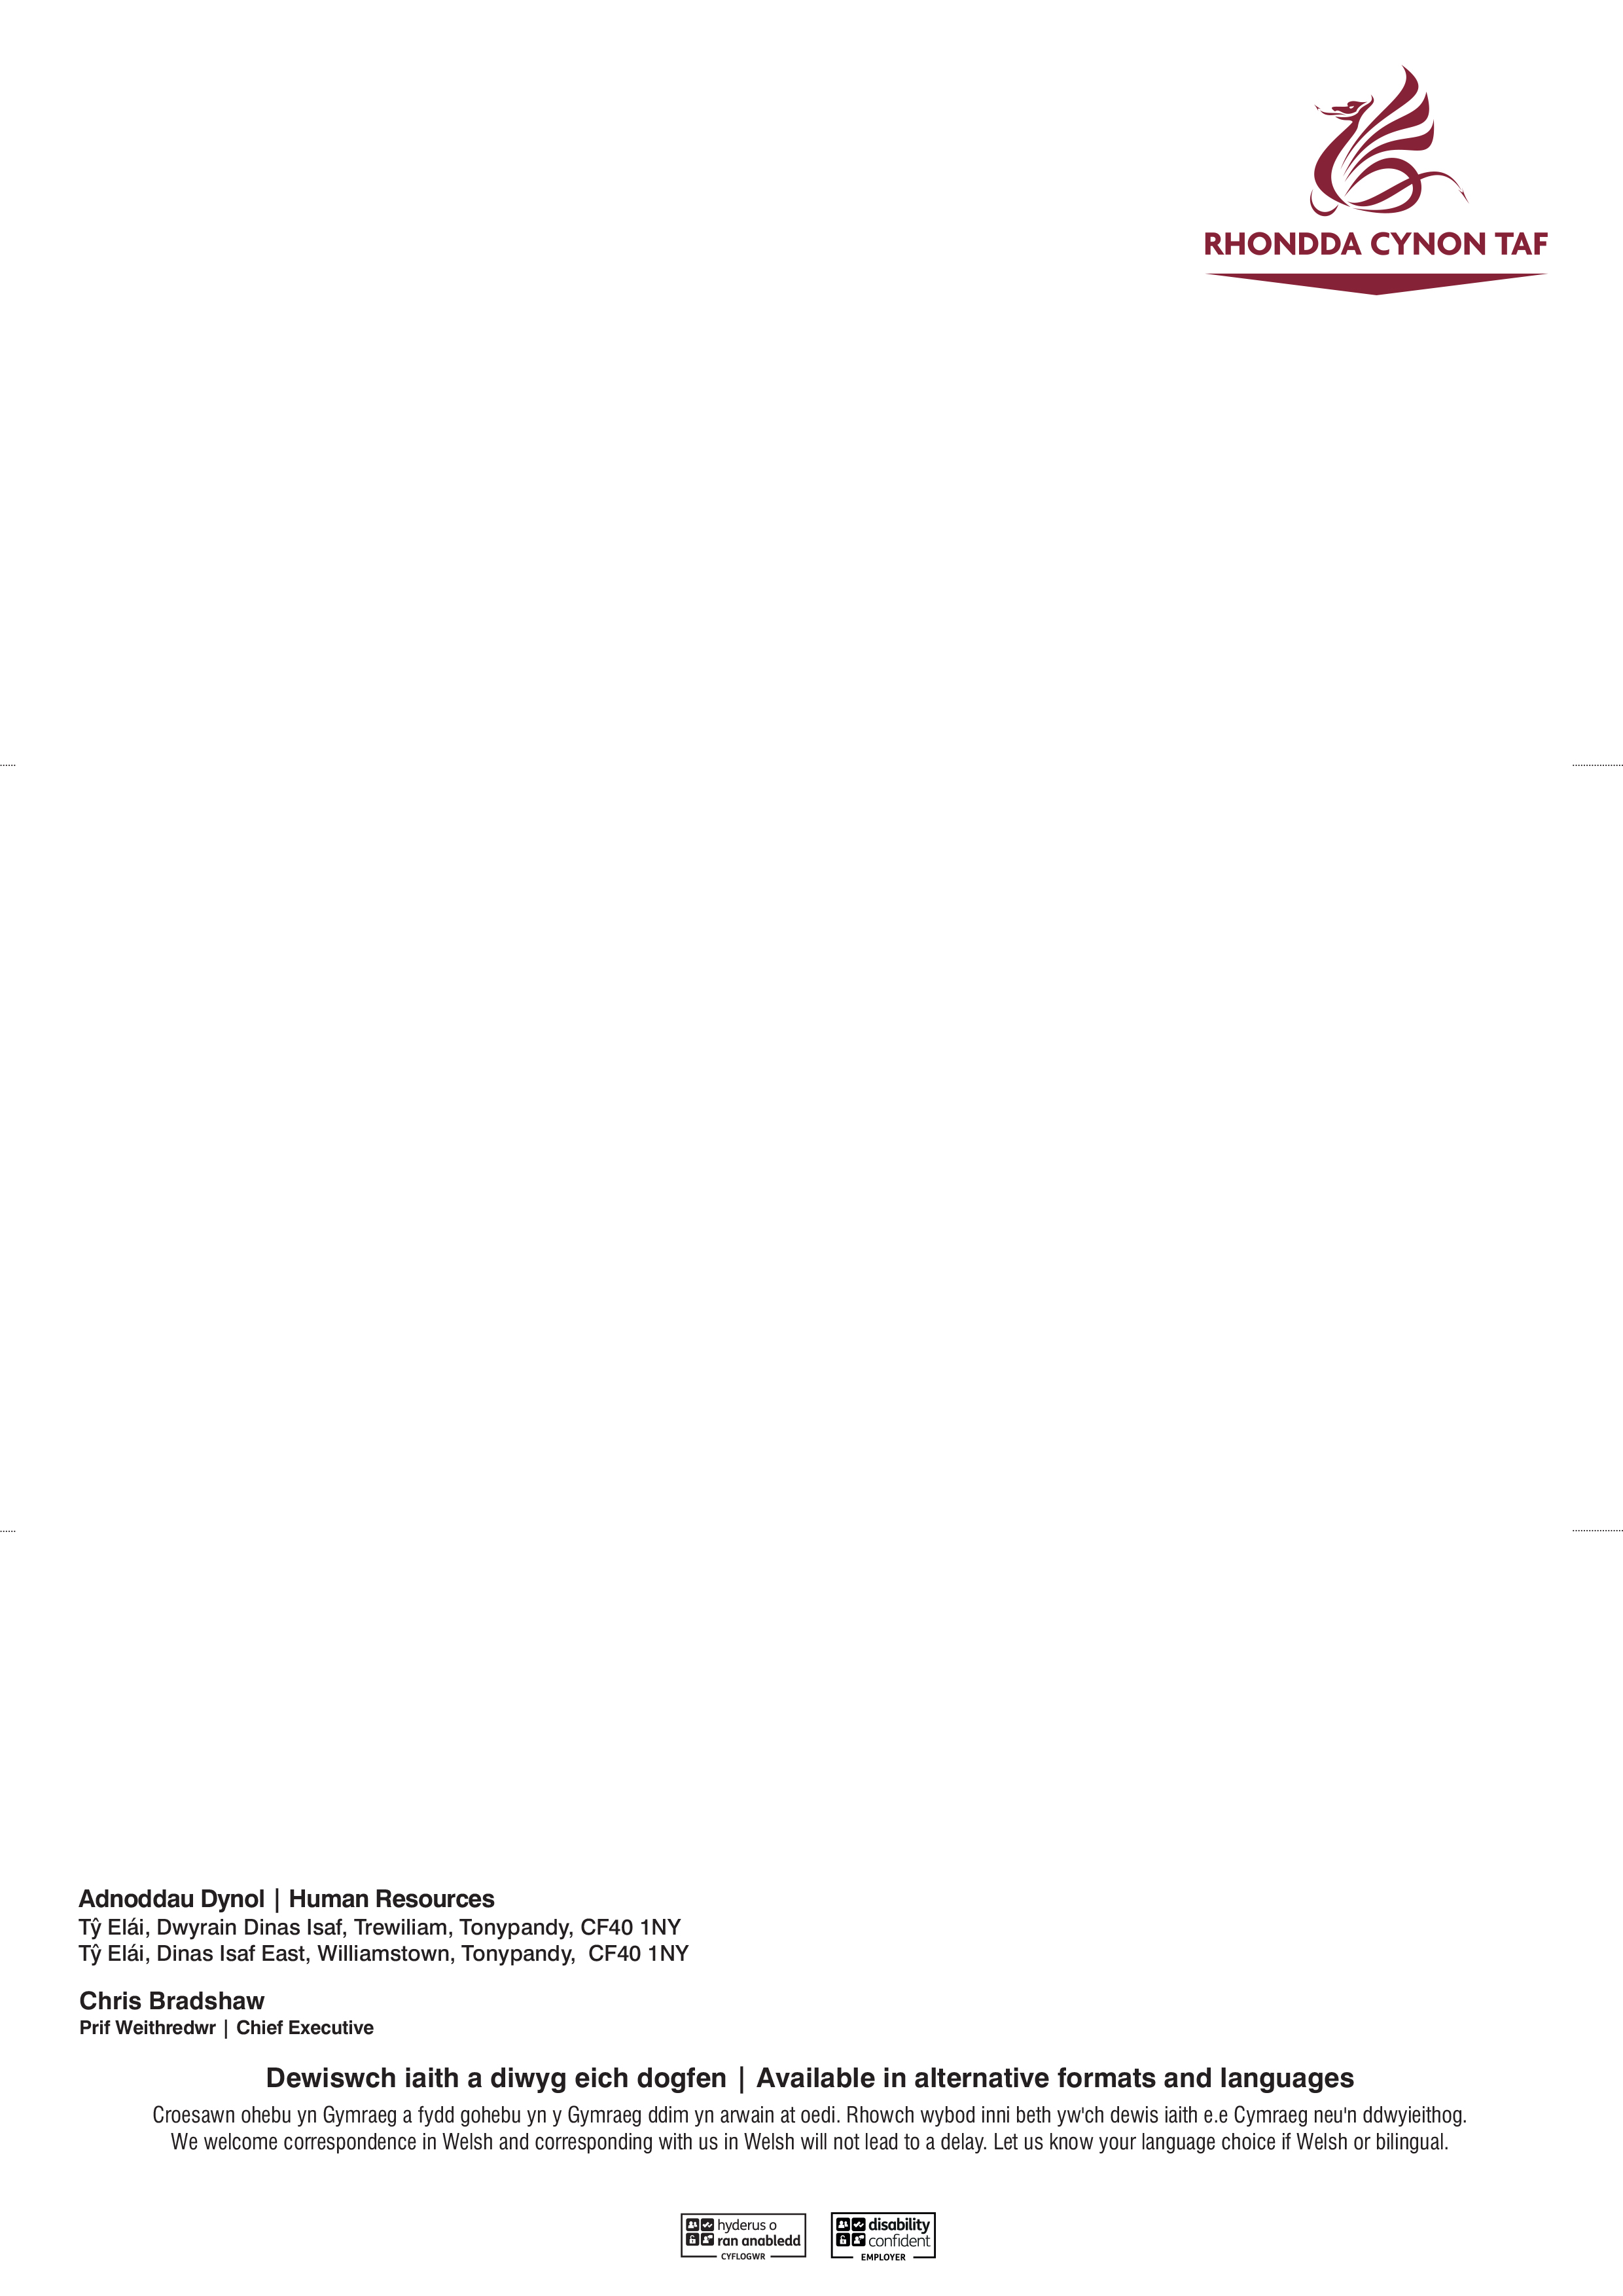****

|  |  |  |
| --- | --- | --- |
| **Name:** | |  |
| **Pay number:** | |  |
| **Date absence commenced:** | |  |
| **Date full pay expires:**  **Date half pay expires:**  **Date fit note expires:** | |  |
| **Reason for absence:** | |  |
| **Interview date:** | |  |
| **Location:** | |  |
| **Visiting Officers:** | |  |
| **Date of Occupational Health reports:** | |  |
| **Officers report on interview** | | |
| **Agreed Actions:** |  | |
| **Officer 1**  **Signed:**  **Post Title:**  **Date:** |  | |
| **Officer 2**  **Signed:**  **Post Title:**  **Date:** |  | |
| **Employee**  **Signed:**  **Post Title:**  **Date:** |  | |

**EMPLOYEE ABSENCE INTERVIEW (SA6)**

The Council is committed to keeping your personal information safe and secure in line with our requirements under the Data Protection Act 2018. Your information will be treated as confidential, but may be shared with relevant Council departments, partner organisations and when required by law. To learn more about how we manage your personal information, please visit our service privacy notice here [www.rctcbc.gov.uk/serviceprivacynotice](http://www.rctcbc.gov.uk/serviceprivacynotice) and the Council’s data protection pages here [www.rctcbc.gov.uk/dataprotection](http://www.rctcbc.gov.uk/dataprotection).

