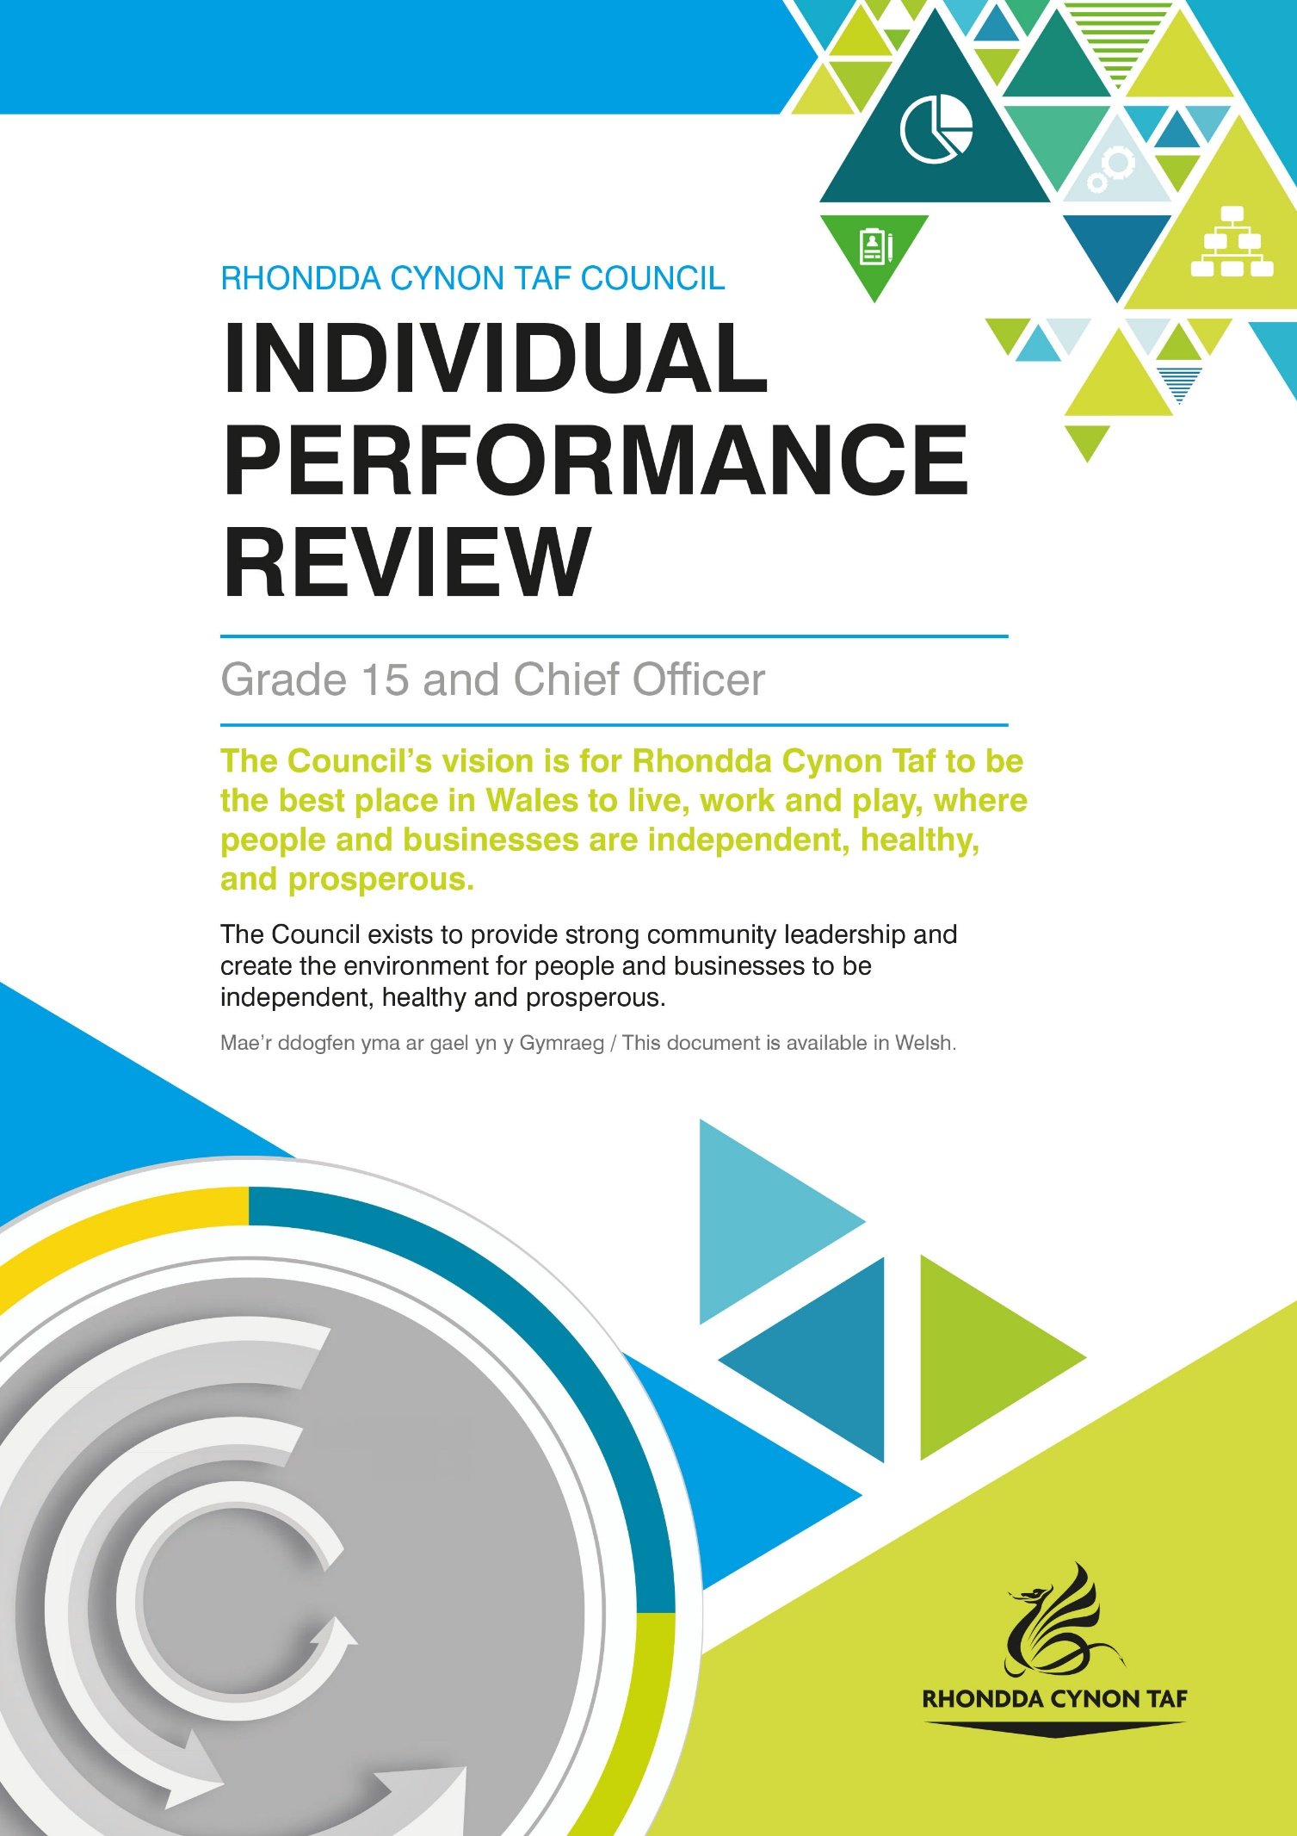
INDIVIDUAL PERFORMANCE REVIEW

This document is to be completed by you during your review with your manager.

Individual Performance Review For:
Date of Review:

HOW WE USE YOUR PERSONAL INFORMATION

The legal basis for Rhondda Cynon Taf County Borough Council (RCTCBC) processing your information under data protection law for performance review purposes is as part of the employment contract, to comply with legal obligations and as part of our public task. To find out more about how we use your information for these purposes, please see the Workforce Administration Privacy Notice and the Council’s data protection pages on the Council website, or email HRPerformanceReview@rctcbc.gov.uk.

You have the right to have your review conducted through the medium of Welsh. Please let your manager know your language preference when arranging your review so that they can make appropriate arrangements (such as simultaneous translation) where necessary.

Managing Performance and Improvement in Rhondda Cynon Taf Council and the Individual Performance Review

The Individual Performance Review will ensure that you are clear about what you are expected to deliver to meet Council priorities, what you are accountable for and what training, support and development opportunities you may need to improve further.

Please note that information from the Individual Performance Reviews and Service Self Evaluations are likely to identify similar themes. Depending on when in the performance cycle your Individual Performance Review is undertaken, the information from one document can be used to inform and strengthen the other.

The Individual Performance Review sets out how you contribute to delivering the Council’s priorities as referenced in the Corporate Plan by:

- reviewing annual progress, you have made in achieving your Delivery Plan objectives
- setting individual targets to improve.

To get the most from your Individual Performance Review you should read through this document beforehand and prepare responses for all sections. You should also consider the answers to the following questions when assessing your performance:

- How well am I doing?
- How do I know?
- How can I improve things further?

In preparation for your review, you will also need the following information:

- employee data for your service area and team
- a copy of your most recent Delivery Plan and monitoring updates
- a copy of your most recent Performance Indicator monitoring sheet

Please ensure you have the most up to date information. All Delivery Plans, monitoring updates and Performance Indicators can be obtained from the shared drive of the Performance Management Team, please contact them if you have any queries.

At the end of each section, you will agree relevant actions with your manager which will lead to personal performance improvement and help deliver Council priorities. You should note these actions on this form and ensure they are monitored on a regular basis as they will be discussed at your next review in 12 months.

This review will provide an opportunity for you to reflect and gain feedback on your performance over the previous 12 months and to set objectives for the future. It also allows you to consider your current role and your next steps in your career.
Please discuss your performance by using your allocated service priorities from your Delivery Plan(s) and associated Performance Indicators (PIs). Actions which are allocated to staff who report to you should also be discussed as you would have overall responsibility for their delivery. Other work or projects that you have undertaken in the last 12 months or are currently involved in should also be noted. Be prepared to discuss your progress against meeting your assigned actions.

You should also identify what information, training or development you need in order to perform at your best to ensure Council priorities and excellent service delivery is achieved.

How would you rate your overall performance in the last year?

The following questions may help facilitate discussion:

- What are you are most proud of and what are your greatest achievements?

- What are your personal strengths in achieving Council priorities?

- Were there any barriers to performance? If there were, what could be done differently to overcome them?

(Objectives set in your previous performance review can also be discussed here)

Please reflect on your leadership or management approach and to assess what key strengths you have called upon to manage your team members, to consider what you have learned since your last review and to determine what support, learning and development you may require that could enable you to be even more effective in your role.

Please use employee data relevant to your area to discuss how your management of staff resources helps deliver Council priorities and how you could improve this further.

The following issues should be discussed, along with anything else you feel is relevant:

- Absence management
- Team performance
- Learning and development (including career development and succession planning)
- Team wellbeing, resilience and flexibility to meet challenges

Collaboration is becoming increasingly important to ensure that excellent services are delivered for residents with no duplication. This is highlighted in the Well-being of Future Generations (Wales) Act 2015, which is about improving the social, economic, environmental and cultural well-being of Wales.

Discuss how well you work with others to ensure objectives are delivered, this can include working with internal services, partnerships, community groups and service users.

Focussing on the next 12 months, what do you need to achieve?

What support do you value from your Manager and what further support would be beneficial in helping you achieve Council priorities?

(It may also be useful to discuss whether you have the resources and tools needed to perform your job and if not, what you require)

What learning and development have you taken part in over the last 12 months?

What future training and skills development do you need for your role, including any qualification renewal?

Development needs can be met in a variety of ways, for example challenging on the job assignments, job rotation, mentoring and coaching, project work, research, training and development courses, e-learning and networking.

Please note training needs identified in this section could be used departmentally to inform future training plans.

If you have any career development plans which have not been covered in the performance review so far, what are they and how could you achieve them?

Is there anything else you would like to raise which you have not had the opportunity to discuss as part of this review?

You may wish to use this template to summarise and monitor the objectives that you have set during this performance review:

Objectives | Progress/notes | Completion Date

When you have completed your review, please sign below:

Sign:
Date:
Manager signature:
Print name:
Date:

We do not require a copy of your review.

When the individual performance review is completed, please ensure that the member of staff and manager retain a copy and store it as confidential for 2 years following date of review completion. You should discuss progress towards achieving goals on a regular basis, for example in 1:2:1s or specific performance review update meetings. If a member of staff has a new manager or moves to a new team or department, the member of staff can share a copy of their review with their new manager to ensure that set goals are still relevant and to agree new goals if appropriate. Please note that some sectors will have their own arrangements for storing and retaining individual performance reviews and may need to keep reviews for longer to comply with statutory requirements. Where this applies, please ensure that you comply with department guidance. Relevant areas where this applies includes social work and social care.

If you have any queries, please do not hesitate to contact HRPerformanceReview@rctcbc.gov.uk. Thank you.

