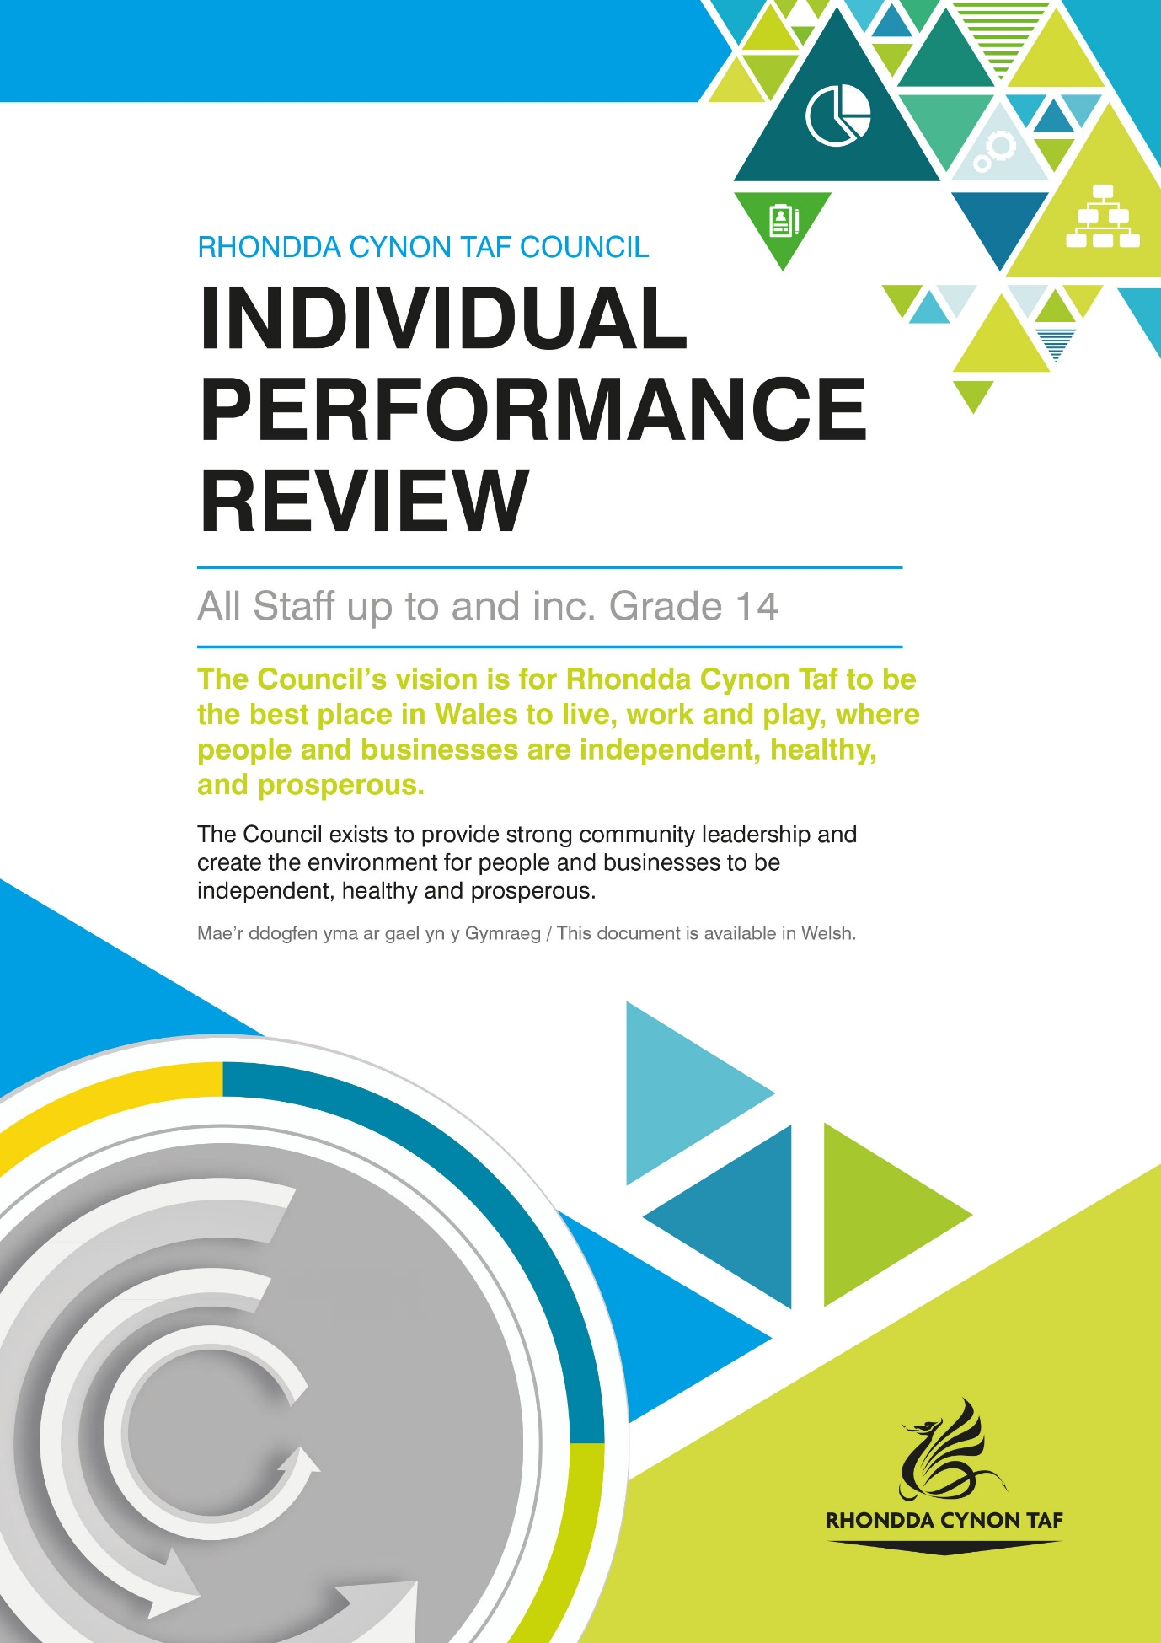

Individual Performance Review

Individual Performance Review For:

Date of Review:

Individual Performance Review Guidance is available on the RCT Source:
Log on>Your Employment>Your Performance
You can also contact HRPerformanceReview@rctcbc.gov.uk with any queries.

HOW WE USE YOUR PERSONAL INFORMATION

The legal basis for Rhondda Cynon Taf County Borough Council (RCTCBC) processing your information under data protection law for performance review purposes is as part of the employment contract, to comply with legal obligations and as part of our public task. To find out more about how we use your information for these purposes, please see the Workforce Administration Privacy Notice and the Council’s data protection pages on the Council website, or contact the Human Resources Workforce Development Team on HRPerformanceReview@rctcbc.gov.uk.

You have the right to have your review conducted through the medium of Welsh. Please let your manager know your language preference when arranging your review so that they can make appropriate arrangements (such as simultaneous translation) where necessary.

Before you start, please answer the following question as it could help to guide discussions, you will be asked it again at the end of the performance review:

To what extent are you clear on your work objectives? (circle answer)

Not at all clear 1 2 3 4 5 Very clear

Please discuss your performance, development and career plans.

Questions have been provided to encourage discussion. Where required, please set clear, agreed objectives and performance development goals with your manager. There is a basic template at the end of this form to record agreed objectives/goals.

Please note some service areas may require evidence of achievements to comply with audit requirements.

PERFORMANCE

Discuss your performance in the last 12 months, for example what are you most proud of, your greatest achievements and challenges?

This text box can be used for notes; for example staff and manager feedback along with any goals set.

Focussing on the next 12 months, what do you need to achieve?

This text box can be used for notes; for example staff and manager feedback along with any goals set.

How can you utilise your strengths and the resources available to you? (e.g. your team, colleagues, networks)

This text box can be used for notes; for example staff and manager feedback along with any goals set.

What support do you need?

This text box can be used for notes; for example staff and manager feedback along with any goals set.

LEARNING, DEVELOPMENT AND CAREER PROGRESSION

What learning and development have you taken part in over the last 12 months?

This text box can be used for notes; for example staff and manager feedback along with any goals set.

What future training and skills development do you need for your role, including any qualification renewal?

Development needs can be met in a variety of ways, for example challenging on the job assignments, job rotation, mentoring and coaching, project work, research, training and development courses, e-learning and networking.

Please note training needs identified in this section could be used departmentally to inform future training plans.

This text box can be used for notes; for example staff and manager feedback along with any goals set.

If you have any career development plans which have not been covered in the performance review so far, what are they and how could you achieve them?

This text box can be used for notes; for example staff and manager feedback along with any goals set.

Is there anything else you would like to raise about your performance and development which you have not had the opportunity to discuss as part of this review?

This text box can be used for notes; for example staff and manager feedback along with any goals set.

MONITORING

It could be useful to set a date for your next meeting.

How will you monitor performance and progress towards meeting objectives with your manager?

 | N/A  (please tick) | Yes  (please tick) | Date
Interim/update performance review

1:1 sessions, supervisions

Team meetings

Other (please specify)

You may wish to use this template to summarise and monitor the objectives that you have set during this performance review:

Objectives | Progress/notes | Completion Date

You may remember that we asked you how clear you were on your work objectives at the start of the review, please answer the question again below. If you are unclear on objectives, you can clarify them with your manager before you finish your review.

To what extent are you clear on your work objectives? (circle answer)

Not at all clear 1 2 3 4 5 Very clear

When you have completed your review, please sign below:

Sign:

Date:

Manager signature:

Print name:

Date:

We do not require a copy of your review. When the individual performance review is completed, please ensure that the member of staff and manager retain a copy and store it as confidential for 2 years following date of review completion. You should discuss progress towards achieving goals on a regular basis, for example in 1:2:1s or specific performance review update meetings. If a member of staff has a new manager or moves to a new team or department, the member of staff can share a copy of their review with their new manager to ensure that set goals are still relevant and to agree new goals if appropriate. Please note that some sectors will have their own arrangements for storing and retaining individual performance reviews and may need to keep reviews for longer to comply with statutory requirements. Where this applies, please ensure that you comply with department guidance. Relevant areas where this applies includes social work and social care.

If you have any queries, please do not hesitate to contact HRPerformanceReview@rctcbc.gov.uk. Thank you.

