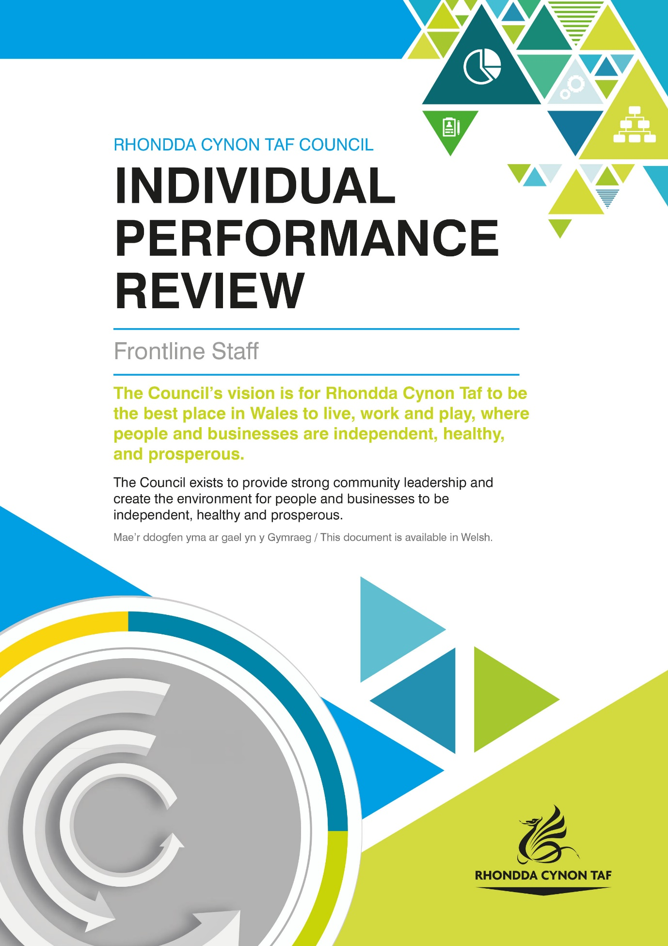

Individual Performance Review

Individual Performance Review For:

Date of Review:

Individual Performance Review Guidance is available on the RCT Source:
Log on>Your Employment>Your Performance
You can also contact HRPerformanceReview@rctcbc.gov.uk with any queries.

HOW WE USE YOUR PERSONAL INFORMATION

The legal basis for Rhondda Cynon Taf County Borough Council (RCTCBC) processing your information under data protection law for performance review purposes is as part of the employment contract, to comply with legal obligations and as part of our public task. To find out more about how we use your information for these purposes, please see the Workforce Administration Privacy Notice and the Council’s data protection pages on the Council website, or contact the Human Resources Workforce Development Team on HRPerformanceReview@rctcbc.gov.uk.

An Individual Performance Review is an opportunity to sit down with your manager to have an open conversation about how you have been doing in your job, the challenges and opportunities that you are facing, support you need to perform well and to identify any development needs and career goals to work towards.

Where required, please set clear, agreed objectives and performance development goals with your manager.

You have the right to have your review conducted through the medium of Welsh. Please let your manager know your language preference when arranging your review so that they can make appropriate arrangements (such as simultaneous translation) where necessary.

Please discuss your performance, development and career plans.
How do you think you have performed in the last 12 months, for example what are you most proud of, your greatest achievements and challenges?

This text box can be used for notes; for example staff and manager feedback along with any goals set.

Thinking about the next 12 months, what are your goals?

This text box can be used for notes; for example staff and manager feedback along with any goals set.

Is there any support or training that you need to do your job and achieve your goals? Do you need any refresher training or have any qualifications that are due for renewal?

This text box can be used for notes; for example staff and manager feedback along with any goals set.

Is there anything else you would like to raise about your performance and development and your career which you have not had the opportunity to discuss as part of this review?

This text box can be used for notes; for example staff and manager feedback along with any goals set.

When you have completed your review, please sign below:

Sign:

Date:

Manager signature:

Print name:

Date:

We do not require a copy of your review. When the individual performance review is completed, please ensure that the member of staff and manager retain a copy and store it as confidential for 2 years following date of review completion. You should discuss progress towards achieving goals on a regular basis, for example in 1:2:1s or specific performance review update meetings. If a member of staff has a new manager or moves to a new team or department, the member of staff can share a copy of their review with their new manager to ensure that set goals are still relevant and to agree new goals if appropriate. Please note that some sectors will have their own arrangements for storing and retaining individual performance reviews and may need to keep reviews for longer to comply with statutory requirements. Where this applies, please ensure that you comply with department guidance. Relevant areas where this applies includes social work and social care.

If you have any queries, please do not hesitate to contact HRPerformanceReview@rctcbc.gov.uk. Thank you.

