Appendix

Risk Assessment (RA) Forms

Issue 2 November 2022

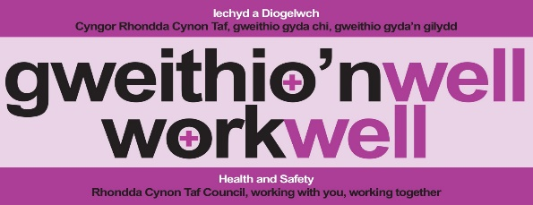

Mae’r ddogfen yma ar gael yn y Gymraeg
This document is available in Welsh

Schedule of Work Activities |  |  | Form RA/01
Service Area: |  | Assessor/s:
Section: |  | Date:
RA Ref No. | List of Work Activities |  | Do known hazards exist?
RA Ref No. |  |  | Yes | Unsure | No

Hazard Identification |  |  |  | Form RA/02
RA Ref No.  (Use your own ref. numbers) |  | Work Activity: |  | Date:
ItemNo. | Hazards associated with activity |  | Is the hazard: |  |  | Degree of  harm
ItemNo. |  |  | Likely |  | Unlikely | H | M | L

Key to risk factor | Risk Factor
Likely to occur x High degree of harm | H
Unlikely to occur x High degree of harm | M
Likely to occur x Medium degree of harm | M
Unlikely to occur x Medium degree of harm | M
Likely to occur x Low degree of harm | L
Unlikely to occur x Low degree of harm (insignificant/trivial) | L
RA Ref: |  | Work Activity Risk Assessment |  |  |  | Form RA/03
Assessment Date |  |  |  | Work Activity being assessed: |  | Assessors:
Review Date
Item No. | Main Hazards  (Something with the potential to cause harm) |  | Risk  [H,M,L] | Reason  (Explain the reasons why you have decided on either a H,M,L risk rating in the previous column. Include the person(s) at risk and the seriousness of the injuries they may sustain) | Current Control Measures  (What are you doing already to control the hazard and risk? These controls must be in place and working effectively) |  | Residual Risk  [H,M.L] | Further Action Required
 |  |  |  |  |  |  |  | Yes | No

Item No. | Main Hazards  (Something with the potential to cause harm) | Risk  [H,M,L] | Reason  (Explain the reasons why you have decided on either a H,M,L risk rating in the previous column. Include the person(s) at risk and the seriousness of the injuries they may sustain) | Current Control Measures  (What are you doing already to control the hazard and risk? These controls must be in place and working effectively) | Residual Risk  [H,M.L] | Further Action Required

Safe to proceed | Yes | No

RA Ref: |  | Risk Assessment – Action Plan |  |  |  | Form RA/04
Responsible Person: |  |  |  | Work Activity: |  | Date:
Designation:
Item No. | Main Hazards |  | Action Required |  | Date Action to be taken by | By Whom | Date Completed

Safe to proceed | Yes | No

RISK ASSESSMENT SUMMARY  (A closer look at the more hazardous areas of concern) |  |  |  |  | Form  RA/05
Ref. No ________ | Work activity:
Service area: |  | Section:
Assessor/s: |  | Date of risk assessment:
Description of work activity:
Description of main hazards and harm |  |  | Control Measures
Who could be harmed?

Additional control measures for this work activity

Where the activity is complex in nature, or requires further understanding, managers should consider developing a Safe Method of Work to support this Risk Assessment.

Council Policy HS6 – Management of Health and Safety at Work
Five Steps to Risk Assessment – INDG163(2) 06/06 – HSE
Managing risks and risk assessment at work:
https://www.hse.gov.uk/simple-health-safety/risk/index.htm?utm_source=hse.gov.uk&utm_medium=refferal&utm_campaign=risk&utm_content=home-page-popular

