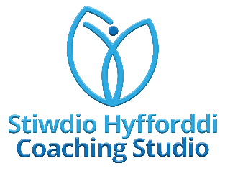

Course Summary
This is primarily a self-directed course with the addition of three Teams meetings with the tutor to track progress, work through any challenges faced and ensure you have guidance and support throughout your journey into carrying out coaching conversations.

Your tutor will be on hand to answer queries and provide guidance and support for the duration of the course.

Week 1:
Teams meeting to introduce the course, what coaching is, how coaching can benefit you and the organisation. Overview and expectations of you and the tutor.

Week 2:
Self-directed learning of up to 1 hour with guidance on The RCT Source.

Week 3:
Self-directed learning of up to 1 hour with guidance on The RCT Source.

Week 4:
Teams meeting with group discussions around the self-directed learning, the coaching carried out, challenges faced and areas for development.

Week 5:
Self-directed learning of up to 1 hour with guidance on The RCT Source.

Week 6:
Self-directed learning of up to 1 hour with guidance on The RCT Source.

Week 7:
Teams meeting with group discussions around the self-directed learning, the coaching carried out, challenges faced and areas for development.
Next steps in your coaching development.

Following the end of the course, the tutor will arrange a 121 coaching conversation session with you to discuss next steps.
Learning Outcomes

After completing this course, learners should:

- Understand the basic principles of coaching

- Be able to explain why coaching is important in an organisational context as a manager / team leader / supervisor

- Be able to carry out a coaching conversation with a staff member or colleague

- Demonstrate a non-directive approach in interactions with staff members and colleagues

- Understand the GROW model

- Be aware of several tools and techniques to aid with coaching conversations in a managerial / team lead / supervisory role

- Understand the next steps to be taken in your coaching journey

